Experiment 9
Aim: Yacc code for the Project number 3.
Input of program- Grammar and input string to be parsed in our project's language
Output of program- appropriate action.
Tools: gcc compiler, Text editor, flex, bison, make.
Procedure:
- Flex code (laymanCalculator.l)
%{
#include<stdio.h>
#include "y.tab.h"
#include<stdlib.h>
extern int yylineno;
extern int yyerror(const char *s);
%}

letter [A-Z]
digit [0-9]
whitespace [ \t\r]+
keyword #START|#END|DECLARE|ASSIGN|ANSWER|RESULT
id {letter}{digit}
operation ADD|SUB|MUL|DIV
word {letter}+
number {digit}+(\.{digit}+)?
eol [\.?]?{whitespace}?[\n]+
comment "**"[^\n]*

%%

{keyword} {
if(!strcmp(yytext, "#START")){
return START;
}else if(!strcmp(yytext, "#END")){
return END;
}else if(!strcmp(yytext, "DECLARE")){
return DECLARE;
}else if(!strcmp(yytext, "ASSIGN")){
return ASSIGN;
}else if(!strcmp(yytext, "ANSWER")){
return ANSWER;
}else if(!strcmp(yytext, "RESULT")){
return RESULT;
}
}
{operation} {
if(!strcmp(yytext, "ADD")){
return ADD;
}else if(!strcmp(yytext, "SUB")){
return SUB;
}else if(!strcmp(yytext, "MUL")){
return MUL;
}else if(!strcmp(yytext, "DIV")){
return DIV;
}
}
{id} {
strcpy(yylval.id, yytext);
return ID;
}
{word} {
strcpy(yylval.word, yytext);
return WORD;
}
{number} {
yylval.number=atof(yytext);
return NUMBER;
}
{eol} {
if(yytext[0]=='.'){
return DOT;
}else if(yytext[0]=='?'){
return QMARK;
}
}
{comment} { }
{whitespace} { }
. {
char msg[256];
sprintf(msg, "Lexical Error : <Invalid symbol : \'%c\'>", yytext[0]);
yyerror(msg);
}
%%

int yywrap(void){
return 1;
}

- Yacc Code (laymanCalculator.y)
%{
#include<stdio.h>
#include<string.h>
#include<stdlib.h>
extern int yylex();
extern int yychar, yylineno;
int yyerror(const char *s);
float answer[50];
int ans_index=0;
%}

%start program
%token <number> NUMBER
%token <word> WORD
%token <id> ID
%token START END DECLARE ASSIGN ANSWER RESULT ADD SUB MUL DIV DOT QMARK
%define parse.error verbose
%union{
float number;
char word[30];
char id[2];
}

%%

program:
START statements END {
printf("#Successfully Compiled.\n");
}
| /* nothing */
;

statements:
statement statements
| /* nothing */
;

statement:
declarestmt
| assignstmt
| operationstmt
| operationonanswerstmt
| resultstmt
;

declarestmt:
DECLARE ID DOT {
printf("ID %s Declared.\n", $2);
}
;

assignstmt:
ASSIGN NUMBER WORD ID DOT { if(strcmp($3, "TO")){
char msg[256];
sprintf(msg, "Semantic Error : <Invalid token : \'%s\'>", $3);
yyerror(msg);
}
printf("Value %f is assigned to ID %s.\n", $2, $4);
}
;

operationstmt:
ADD NUMBER WORD NUMBER DOT {
if(strcmp($3, "TO") && strcmp($3, "WITH")){
char msg[256];
sprintf(msg, "Semantic Error : <Invalid token : \'%s\'>", $3);
yyerror(msg);
}
answer[ans_index++] = $2 + $4;
printf("%f is added in %f and answer is %f.\n", $4, $2, answer[ans_index-1]);
}
| SUB NUMBER WORD NUMBER DOT {
if(strcmp($3, "FROM")){
char msg[256];
sprintf(msg, "Semantic Error : <Invalid token : \'%s\'>", $3);
yyerror(msg);
}
answer[ans_index++] = $4 - $2;
printf("%f is subtracted from %f and answer is %f.\n", $2, $4, answer[ans_index-1]);
}
| MUL NUMBER WORD NUMBER DOT {
if(strcmp($3, "TO") && strcmp($3, "WITH")){
char msg[256];
sprintf(msg, "Semantic Error : <Invalid token : \'%s\'>", $3);
yyerror(msg);
}
answer[ans_index++] = $2 * $4;
printf("%f is multipled with %f and answer is %f.\n", $2, $4, answer[ans_index-1]);
}
| DIV NUMBER WORD NUMBER DOT {
if(strcmp($3, "BY")){
char msg[256];
sprintf(msg, "Semantic Error : <Invalid token : \'%s\'>", $3);
yyerror(msg);
}
answer[ans_index++] = $2 / $4;
printf("%f is divided by %f and answer is %f.\n", $2, $4, answer[ans_index-1]);
}
;

resultstmt:
WORD WORD RESULT QMARK {
if(strcmp($1, "WHAT")){
char msg[256];
sprintf(msg, "Semantic Error : <Invalid token : \'%s\'>", $1);
yyerror(msg);
}
if(strcmp($2, "IS")){
char msg[256];
sprintf(msg, "Semantic Error : <Invalid token : \'%s\'>", $2);
yyerror(msg);
}
printf("The final result : %f.\n", answer[ans_index]);
printf("Final result displayed.\n");
}
;

operationonanswerstmt:
WORD ADD WORD ANSWER DOT {
if(strcmp($1, "NOW")){
char msg[256];
sprintf(msg, "Semantic Error : <Invalid token : \'%s\'>", $1);
yyerror(msg);
}
float tmp=answer[0];
for(int i=1; i<ans_index; i++)
tmp += answer[i];
answer[0]=tmp;
ans_index=0;
printf("%s answer are added\n", $3);
}
| WORD SUB WORD ANSWER DOT {
if(strcmp($1, "NOW")){
char msg[256];
sprintf(msg, "Semantic Error : <Invalid token : \'%s\'>", $1);
yyerror(msg);
}
float tmp=answer[0];
for(int i=1; i<ans_index; i++)
tmp -= answer[i];
answer[0]=tmp;
ans_index=0;
printf("%s answer are subtracted\n", $3);
}
| WORD MUL WORD ANSWER DOT {
if(strcmp($1, "NOW")){
char msg[256];
sprintf(msg, "Semantic Error : <Invalid token : \'%s\'>", $1);
yyerror(msg);
}
float tmp=answer[0];
for(int i=1; i<ans_index; i++)
tmp *= answer[i];
answer[0]=tmp;
ans_index=0;
printf("%s answer are multipled\n", $3);
}
| WORD DIV WORD ANSWER DOT {
if(strcmp($1, "NOW")){
char msg[256];
sprintf(msg, "Semantic Error : <Invalid token : \'%s\'>", $1);
yyerror(msg);
}
float tmp=answer[0];
for(int i=1; i<ans_index; i++){
if(answer[i]==0.0 || tmp==0.0){
char msg[256];
sprintf(msg, "Math error : Divide by 0 due to answer number %d.\n", i+1);
yyerror(msg);
}
tmp /= answer[i];
}
answer[0]=tmp;
ans_index=0;
printf("%s answer are divided\n", $3);
}
;

%%

void main(int argc, char *argv[]){
if(argc != 2){
printf("Enter this way please : ./a.out filename\n");
exit(0);
}
extern FILE *yyin;
yyin = fopen(argv[1], "r");
yyparse();
printf("\n");
}

int yyerror(const char *errormsg)
{
fprintf(stderr, "at line %d :- %s\n", yylineno, errormsg);
exit(1);
}

- Make File
start:
flex -l laymanCalculator.l
bison -dy laymanCalculator.y
gcc lex.yy.c y.tab.c -o lamcal

- Input/Output
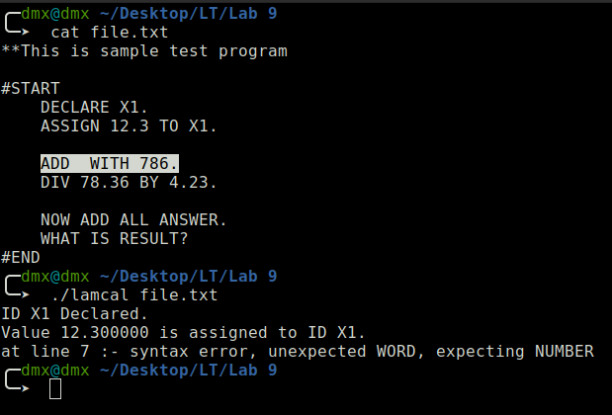

Fig 9.1 Syntax Error
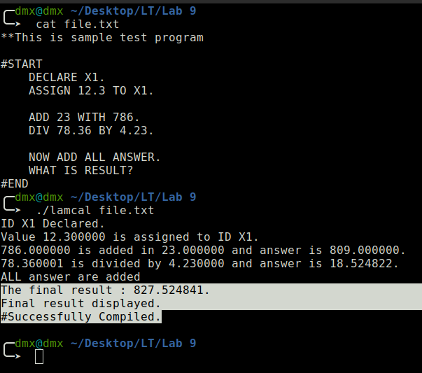

Fig 9.2 No Error in input file
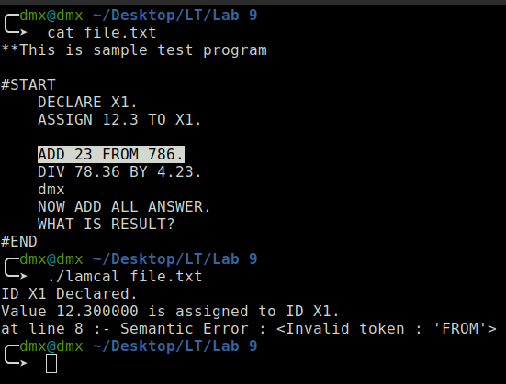

Fig 9.3 Semantic Error
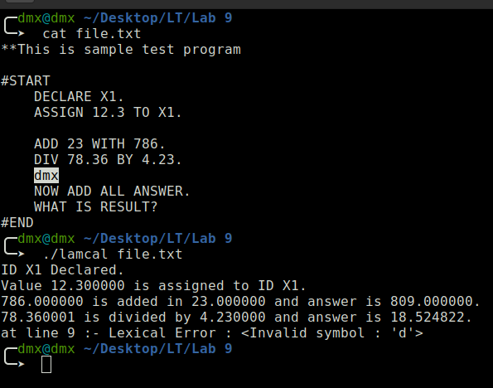

Fig 9.4 Lexical Error

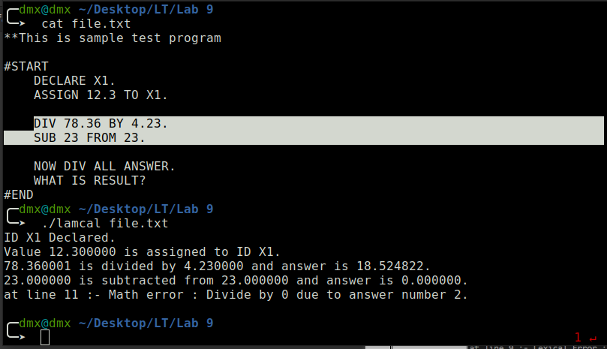

Fig 9.5 Math Error

